Sandstone Intermediate Camp
July 8-11, 2019
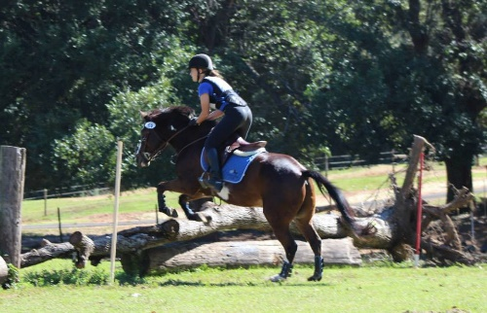
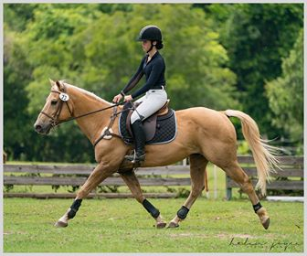
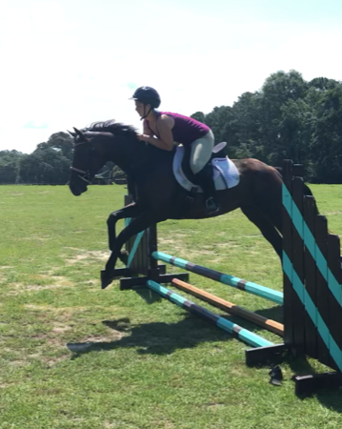

For students currently in the Sandstone lesson program/or students who are able to walk/trot/canter independently and jump small fences.
Intermediate camp will be a week full of riding dressage, cross country, stadium and conditioning.
In addition to riding campers will learn in-depth about the sport of Eventing and what it takes to care for their equine partner such as feed, leg wrapping, horses fitness, parts of the horse, proper show prep and much more.

Cost of this camp - $325.00/ Current Sandstone lesson students $275.00 (4 or more per month)
$100 deposit due by June 1st.
Monday-Thursday 8-3:30.

Campers need to bring a lunch, bathing suite, and change of clothes. If any additional items are needed I will send out a list closer to the dates of camp.

Name______________________________________________ Age __________

Address_______________________________________________________________

Parent/Guardian: _______________________________________________________

Phone #’s _______________________________________________________________

Doctor:____________________ Phone: ___________________ Allergies:____________

Camp Date(s) Desired:________________________________ T-Shirt Size ___________

