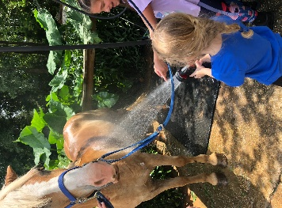
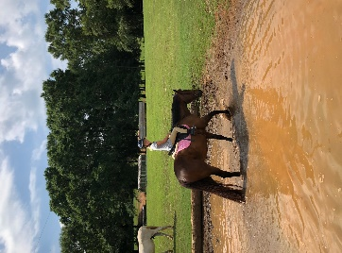
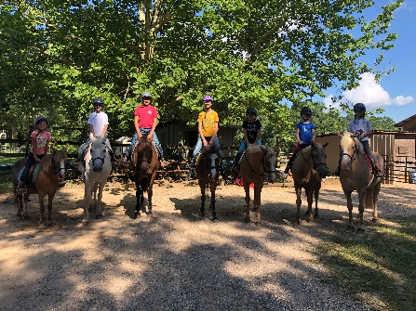
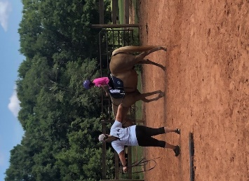
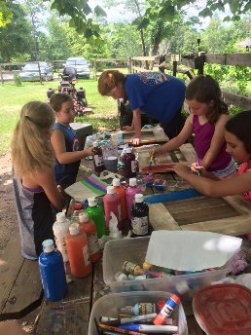
Sandstone Equestrian Center Summer Camps 2024
Summer Camp Dates: June 3-6, June 17-20, July 22-25.
Time: 8-2:00 Monday-Thursday
Open to Ages: 5-15
Cost- $350 ($50.00 discount if more than one child attends or lesson students that take 4 or more lessons a month)
Sandstone summer camps are open to riders of all levels. During camp we focus on learning the basics of English riding, safety around horses, basic horse care, games on horseback, stable management and veterinary care. We also go swimming and make a horsey craft each day. We cater to each individual campers needs in a small group riding situation. Campers need to bring their own helmet, the helmet must be a certified horse riding helmet I have attached links to helmets below. Students will also need to bring a lunch, drink and snack, bathing suite, towel and change of clothes. Riders need to wear comfortable long pants and boots with a heel for riding.
Complete following form and mail/email or complete the google doc https://forms.gle/prF9DHVG2WMiR2d1A with a $100.00 deposit to 9450 A Jeff Hamilton Rd. Mobile, AL 36695 by May 20th to hold your spot.
Please Call or email Stephanie Tyler-Wright at 251-508-2759/sandstoneec@gmail.com with any questions.

Name______________________________________________ Age __________

Address_________________________________ Email Address____________________

Parent/Guardian: _______________________________________________________

Phone #’s _______________________________________________________________

Doctor:____________________ Phone: ___________________ Allergies:____________

Camp Date(s) Desired:________________________________ T-Shirt Size ___________

Photo Release
I DO / DO NOT (please circle one) consent to and authorize the use and reproduction by Sandstone Equestrian Center of any photographs and any other audio-visual materials taken of me for promotional material, educational activities, exhibitions or for any other use for the benefit of the program.
Signature_________________________________________________________ Date_________
(Parent or Guardian Signature if under 18 years of age) _______________________________________
Release of Liability
In consideration of being allowed to participate in any way in activities at the property belonging to Mr. and Mrs. Henry H. McCawley, and Mr. Aaron K. Rhea, located at 9450 and 9450- A Jeff Hamilton Road, Mobile, AL and its related properties, events and activities, I (print riders name)________________________________________, agree the undersigned acknowledge, appreciate and agree that:
- The risk of injury from involvement in an equestrian activity is significant, including the potential for permanent paralysis and death, and while particular skills, equipment, and personal discipline may reduce the risk. The risk of serious injury does still exist: and,
- I understand that my activities involve all inherent risks associated with the dangers and conditions which are an integral part of equine activities, including, but not limited to, the propensity of equines to behave in ways which may result in injury, harm, or even death to humans or other animals around or near them; the unpredictability of equine reaction to sounds, sudden movements, smells and unfamiliar objects; persons or animals; hazards relate to surface and subsurface conditions; collisions with other equines or objects, and the potential of another to act in a negligent or unskilled manner which may contribute to injury to myself or others, including falling or inability to maintain control over the animal.
- I KNOWINGLY AND FREELY ASSUME ALL SUCH RISKS, both known and unknown. EVEN IF ARISING FROM THE NEGLIGENCE OF THE RELEASEES or others, and assume full responsibility for my activities,
- I willingly agree to comply with the stated and customary terms and conditions for my activities. If however, I observe and unusual significant hazard during my presence or participation, I will remove myself from participation, discontinue my activity and bring such to the attention of Mr. and Mrs. Henry H. McCawley, or Mr. Aaron K. Rhea immediately.
- I, for myself and on behalf of my heirs, assigns, personal representatives and next of kin, HEREBY RELEASE INDEMNIFY, AND HOLD HARMLESS Mr. and Mrs. Henry H. McCawley and Mr. Aaron K. Rhea, their heirs, officials, agents and/or employees, other participants, sponsoring agencies, advertisers, and if applicable, owner and lessors or premises (“Releasees”). WITH RESPECT TO ANY AND ALL INJURY, DISABILITY, DEATH or loss or damage to person or property, including the horses or horses with which I am involved, WHETHER ARISING FROM THE NEGLIGENCE OF THE RELEASES OR OTHERWISE, to the fullest extent permitted by law.
I HAVE READ THIS RELEASE OF LIABILITY AND ASSUMPTION OF RISK AGREEMENT, FULLY UNDERSTAND ITS TERMS, UNDERSTAND THAT I HAVE GIVEN UP SUBSTANTIAL RIGHTS BY SIGNING IT FREELY AND VOLUNTARILY WITHOUT AND INDUCEMENT. UNDER ALABAMA LANW AN EQUINE ACTIVITY OR SPONSOR OR EQUINE PROFESSIONAL IS NOT LIABLE FOR AN INJURY TO OR THE DEATH OF A PARTICIPANT IN EQUINE ACTIVITIES RESULTING FROM THE INFERENT RISKS OF EQUINE ACTIVITES, PURSUANT TO THE EQUINE ACTIVITIES LIABILITY PROTECTION ACT.
Sign: _________________________________________Age:_______________Date:__________________
Print name: ____________________________________ Phone #: _________________________________
For Parents/Guardians of Riders of Minority Age
(Under Age 18 at the time of signing)

This is to certify that I, as a parent/guardian with legal responsibilities for this rider, do consent and agree to his/her release as provided above of all the Releasees, and, for myself, my heirs, assigns, and next of kin, I release and agree to indemnify and hold harmless the Releasees from any and all liabilities incident to my minor child’s activities, involvement or participation at this facitiliy, related properties, events and activities as provided above, EVEN IF ARISING FROM THE NEGLIGENCE OF THE RELEASEES, to the fullest extent permitted by law.
Sign: ________________________________ Age: ________________ Date: ________________________
Print name:___________________________________ Phone #:__________________________________

